Spring 2019
CLCS 234:
MEDICAL AND SCIENCE TERMINOLOGY FROM
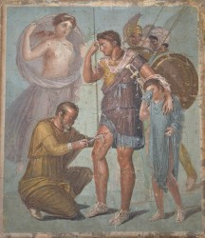
GREEK AND LATIN ROOTS
3 CREDIT HOURS
NO PREREQUISITE
FOR MORE INFORMATION CONTACT: Liz Mercier: eemercie@purdue.edu

